Tests

Results

# orientation

The results are placed in the following files:

* OrientationTestGraph.xlsx: this files contains the graph and the data for that graph
* OrientationTestTimingandResults.xlsx: contains the timing information when the samples were taken and the according results

## set up

Two Telos rev. B nodes were set in the outdoor environment. The test exists out of two parts: In the first part, the two nodes are equipped with an external antenna with a gain of 6dBi and placed at a distance of one meter and at a distance of five meters from each other at a height of one meter. This way the ground will attenuate the signal. One node is set as an anchor node and will broadcast beacon messages at a rate of 200 ms. The anchor node was rotated and samples were taken at every 20 degrees. The other node, the blind node sends the RSS readings to the database. Approximately 25 samples were collected at every orientation.

In the second part, only one node is equipped with the external antenna and placed at a distance of one and five meter. This node is set as the blind node and receives ideally the same power in every direction. The other node with an integrated antenna is the anchor node that will broadcast the beacon messages.

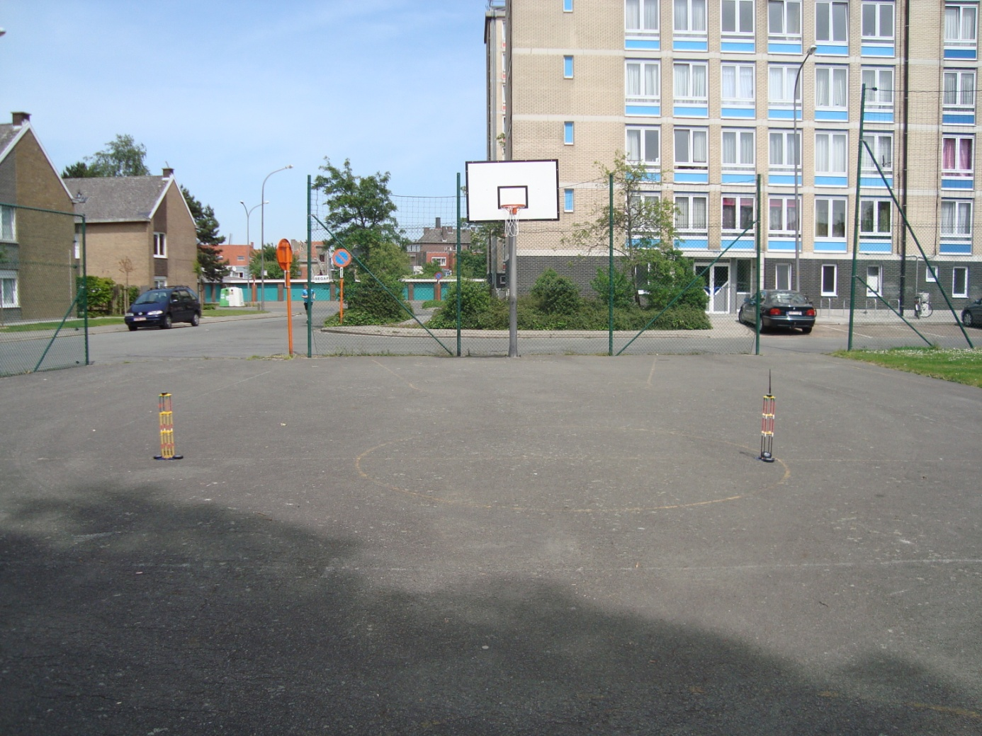

## result

Set up with 1 external antenna

Set up with 2 external antennas

# position error of algorithms

The results are for indoor are placed in the following files:

* IndoorGraph.xlsx: this files contains the graph and the data for that graph
* IndoorTiming.xlsx: contains the timing information when the samples were taken
* IndoorDatabase.xlsx: contains the database for the interval of the test
* Indoor3Anchors.xlsx: contains the calculated results for 3 anchors
* Indoor5Anchors.xlsx: contains the calculated results for 5 anchors
* Indoor7Anchors.xlsx: contains the calculated results for 7 anchors
* Indoor9Anchors.xlsx: contains the calculated results for 9 anchors

The results are for outdoor are placed in the following files:

* OutdoorGraph.xlsx: this files contains the graph and the data for that graph
* OutdoorTiming.xlsx: contains the timing information when the samples were taken
* OutdoorDatabase.xlsx: contains the database for the interval of the test
* Outdoor3Anchors.xlsx: contains the calculated results for 3 anchors
* Outdoor5Anchors.xlsx: contains the calculated results for 5 anchors
* Outdoor7Anchors.xlsx: contains the calculated results for 7 anchors
* Outdoor9Anchors.xlsx: contains the calculated results for 9 anchors

## setup

We placed a total of 10 nodes in both the indoor and outdoor environment. Nine of them are configured as anchor nodes and the last one if configured as a blind node. Every node is placed at a height of one meter. The anchor nodes are placed randomly at fixed locations (in meters):

* Node one: 1.19 ; 6.98
* Node two: 2.00 ; 8.48
* Node three: 3.00 ; 1.50
* Node four: 3.19 ; 6.23
* Node five: 1.19 ; 5.14
* Node six: 4.64 ; 3.88
* Node seven: 4.67 ; 0.00
* Node eight: 2.50 ; 0.00
* Node nine: 0.00 ; 0.00

The blind node will be located at the following locations (in meters):

1. 5.07 ; 8. 48
2. 5.07; 4.63
3. 2.00 ; 1.50
4. 0.00 ; 3.29
5. 3.19 , 6.23
6. 1.19 , 8.48

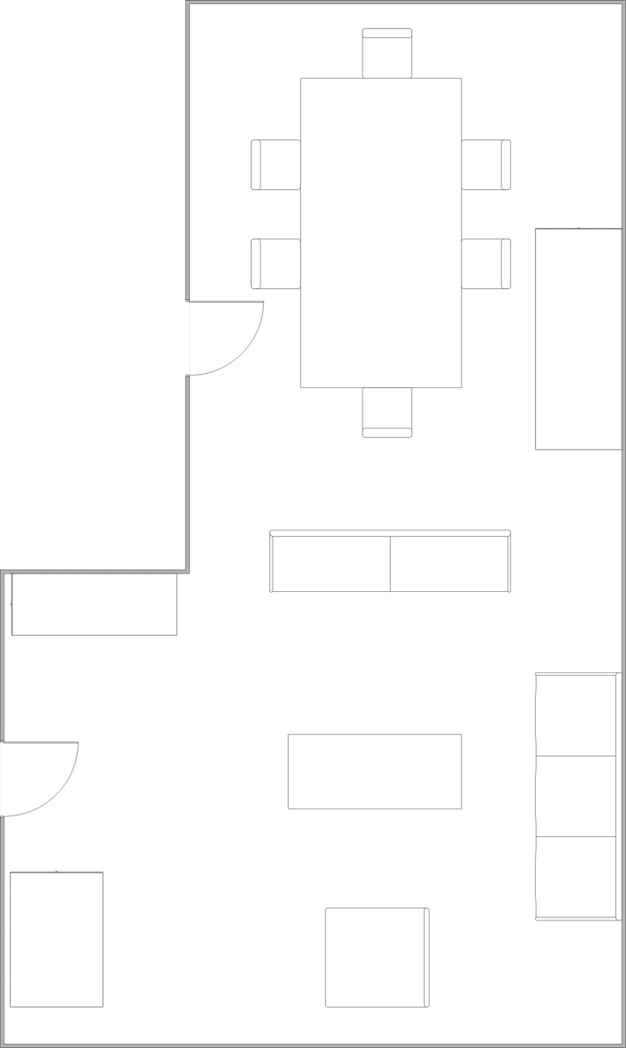

### results (indoor)

|  |  |  |  |  |
| --- | --- | --- | --- | --- |
| **Number of anchor nodes** | 3 | 5 | 7 | 9 |
| **Centroid localization** |  |  |  |  |
| Relative position error (%) | 0,7041679 | 0,7178535 | 0,7361435 | 0,711895 |
| Standard deviation | 0,2085483 | 0,161636 | 0,1378752 | 0,13499 |
| **Weighted Centroild localization** |  |  |  |  |
| Relative position error (%) | 0,670399 | 0,64111 | 0,6043655 | 0,567713 |
| Standard deviation | 0,282125 | 0,1870517 | 0,2118316 | 0,295417 |
| **Min-Max** |  |  |  |  |
| Relative position error (%) | 0,6733023 | 0,5805728 | 0,519601 | 0,609186 |
| Standard deviation | 0,3340315 | 0,1126369 | 0,2288376 | 0,333507 |
| **Trilateration** |  |  |  |  |
| Relative position error (%) | 0,6335248 | 1,2454727 | 1,0052603 | 0,69328 |
| Standard deviation | 0,2460398 | 0,938236 | 0,983869 | 0,421257 |
| **Trilateration with least square** |  |  |  |  |
| Relative position error (%) | 2,5785385 | 3,2582359 | 4,6995101 | 2,702967 |
| Standard deviation | 4,5778676 | 3,4127893 | 6,0744286 | 3,375513 |

### results (outdoor)

|  |  |  |  |  |
| --- | --- | --- | --- | --- |
| **Number of anchor nodes** | 3 | 5 | 7 | 9 |
| **Centroid localization** |  |  |  |  |
| Relative position error (%) | 0,759873 | 0,724016 | 0,735404 | 0,715881 |
| Standard deviation | 0,194748 | 0,132251 | 0,124058 | 0,125944 |
| **Weighted Centroild localization** |  |  |  |  |
| Relative position error (%) | 0,759827 | 0,64602 | 0,661308 | 0,627102 |
| Standard deviation | 0,174093 | 0,183463 | 0,160361 | 0,154578 |
| **Min-Max** |  |  |  |  |
| Relative position error (%) | 0,780401 | 0,529461 | 0,513403 | 0,551327 |
| Standard deviation | 0,214815 | 0,342726 | 0,287978 | 0,218043 |
| **Trilateration** |  |  |  |  |
| Relative position error (%) | 0,769262 | 0,573275 | 0,556054 | 0,755345 |
| Standard deviation | 0,271507 | 0,345707 | 0,276033 | 0,297375 |
| **Trilateration with least square** |  |  |  |  |
| Relative position error (%) | 1,564793 | 1,09579 | 0,834139 | 1,587507 |
| Standard deviation | 0,849787 | 0,93364 | 0,238267 | 1,361935 |